TITLE: IMPLEMENTATION OF MQTT PUBLISH–SUBSCRIBE COMMUNICATION USING ESP32

COURSE LEARNING OUTCOME (CLO):

CLO2: construct various types of input/output applications, data acquisition and communication using the IoT platform. (P4, PLO5)

1. OBJECTIVE:
At the end of this practical work, student should be able to:
i) Install and configure Arduino IDE for ESP32 DEVKIT NodeMCU-32S board correctly.
ii) Create a project file and write a simple code using Node MCU correctly.
iii) Construct a simple hardware connection and perform compiling, uploading and testing.

2. EQUIPMENTS & COMPONENTS:
No Component Quantity
1 ESP32 DEVKIT V1 1
2 USB to Micro-USB cable 1

3. INTRODUCTION / THEORY:

Message Queuing Telemetry Transport (MQTT) is a lightweight communication protocol widely used in Internet of Things (IoT) applications. It is designed for devices with limited processing power and low network bandwidth, such as microcontrollers. MQTT enables reliable data communication between devices, platforms, and user applications.
In this practical work, MQTT communication is implemented using an ESP32. The ESP32 is configured as an MQTT client to publish and subscribe simple messages through an MQTT broker. By sending basic control messages such as ON and OFF, the operation of MQTT communication can be clearly observed. This practical provides a basic understanding of how IoT devices communicate using the MQTT protocol.

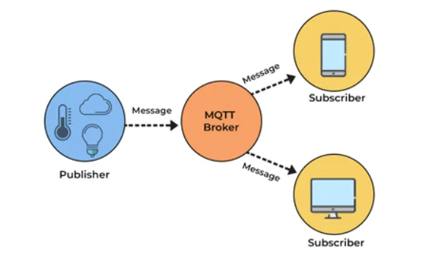
MQTT operates using a publish–subscribe communication model, where devices do not communicate directly with each other. Instead, all messages are managed by an MQTT broker. The MQTT system consists of three main components: publisher, subscriber, and broker.
A publisher is a device or application that sends data to a specific topic. A subscriber receives data by subscribing to a topic. The MQTT broker acts as a central server that receives messages from publishers and forwards them to the appropriate subscribers based on the topic.
Topics are text-based labels used to organize MQTT messages. Devices can subscribe to or publish data using these topics without knowing the identity of other devices. This makes MQTT flexible and scalable for IoT systems.
In this practical work, the ESP32 functions as an MQTT client. It connects to the internet and communicates with the MQTT broker. The ESP32 subscribes to a control topic to receive ON/OFF commands and publishes status messages to indicate the device condition. This demonstrates basic MQTT communication for IoT device control.
PROCEDURE
Task 1
Node red setup in browser
- Install Node Red (skip this if u already done install)
  - Install node js
  - Run command prompt and install Node Red
  - Run Node Red local server (do not close during using node-red)
  - Install palette dashboard @flowfuse/node-red-dashboard

- Open Node Red on browser
- Setup nodes as shown below

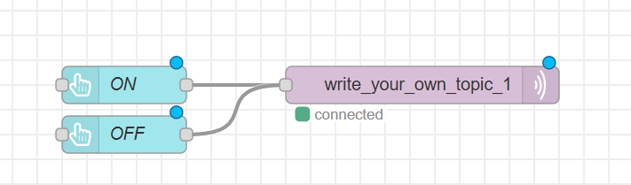

- Setup MQTT OUT nodes

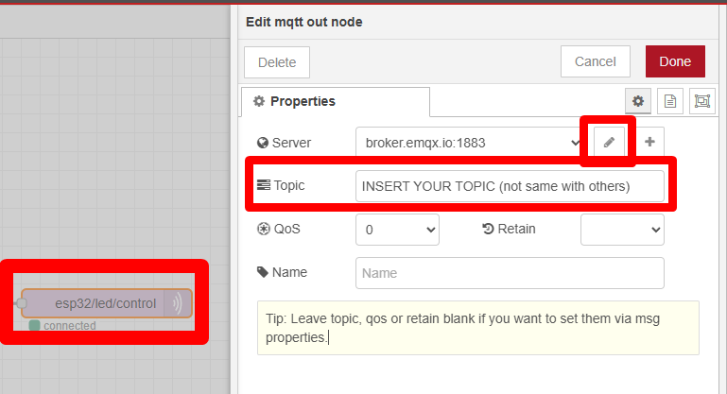

- Set the publish topic name (make sure set same when set the codes in Arduino IDE)
- This topic must match exactly with the subscribe topic defined in the ESP32 program later.
- Topic must be unique, case sensitive and not same with others
- Example topic name pw4/mqtt
- Click pencil to set the Broker Server
- Set Broker to broker.emqx.io

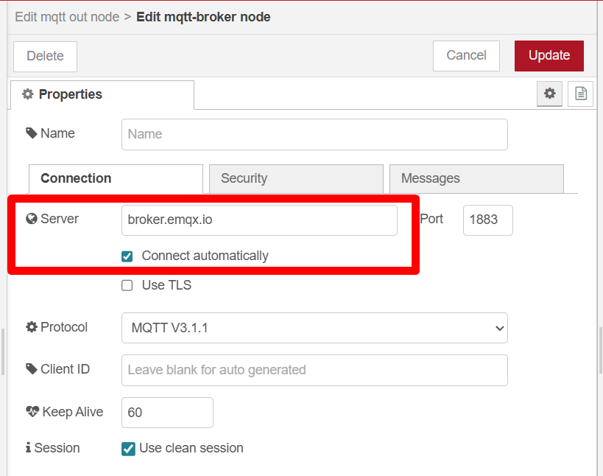

- Setup button ON
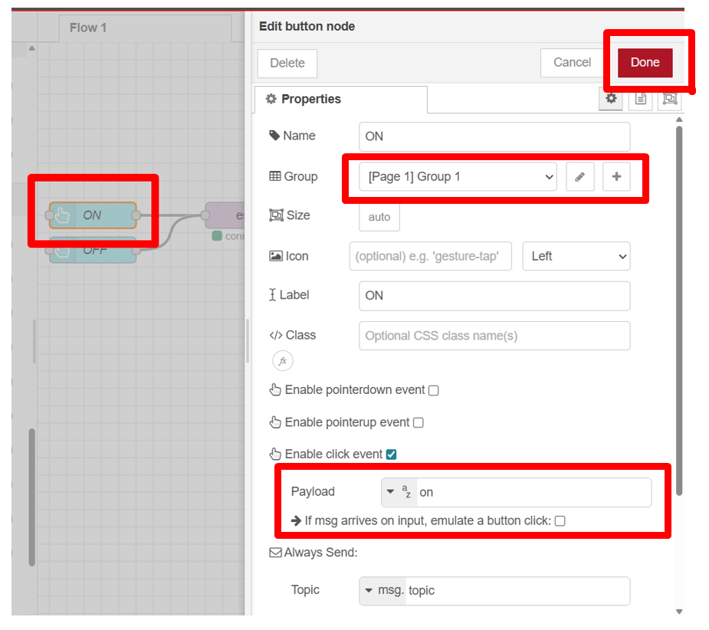

- Setup button OFF

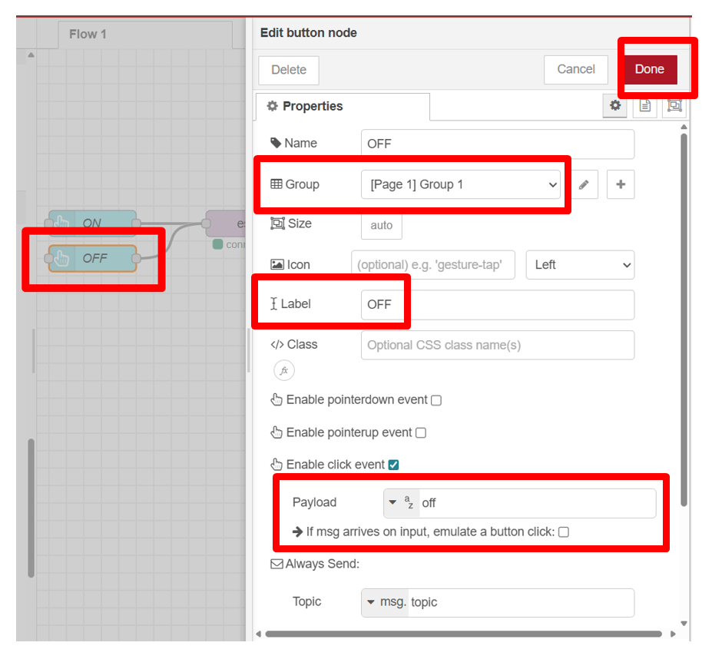

- Complete the setting
- Connect the nodes
- Deploy the nodes

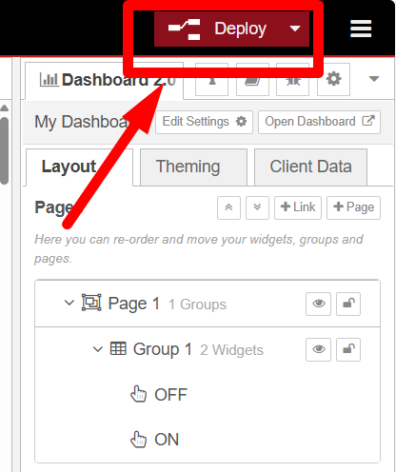

- After deploy, check nodes is “green” connected. This show all setup is correct.
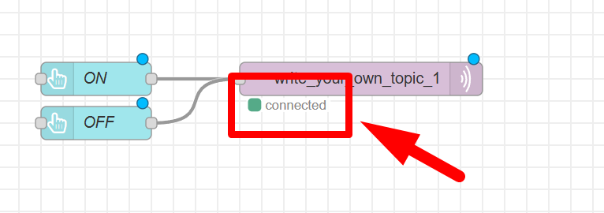

- Open deploy dashboard, by clicking “open dashboard”
- A new window / tab in browser will be open

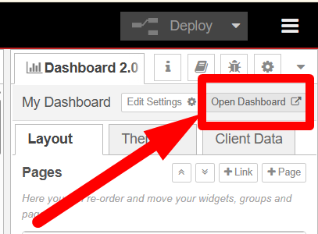

- The deployed dashboard in browser, is shown below.

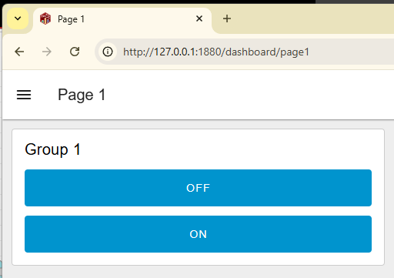

Circuit Setup using Hardware
- Connect the Hardware
- Refer the schematic diagram provided
- Check polarity and resistor value to make all will function properly

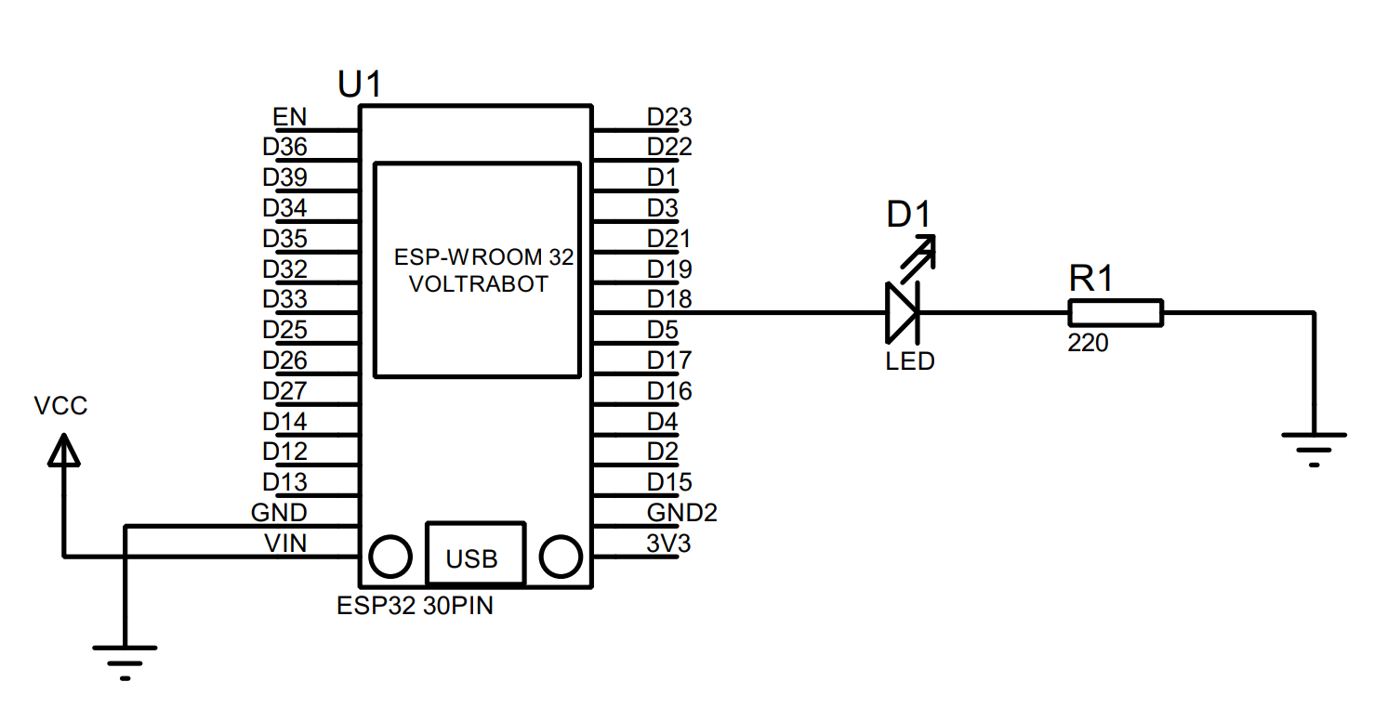
- Continue the setup for Arduino IDE

Library setup in Arduino IDE
- Connect the Hardware
- Connect the ESP32 to your computer using a USB cable.
- Make sure the onboard LED of the ESP32 (GPIO 2) is used as an output indicator.
- Open the Arduino IDE.
- Select the board DO IT ESP32 DEVKIT.
- Select the correct COM port.
- Make sure the following library has been installed:
- PubSubClient.h – Download it using the link below.
https://github.com/knolleary/pubsubclient
- How to download the library
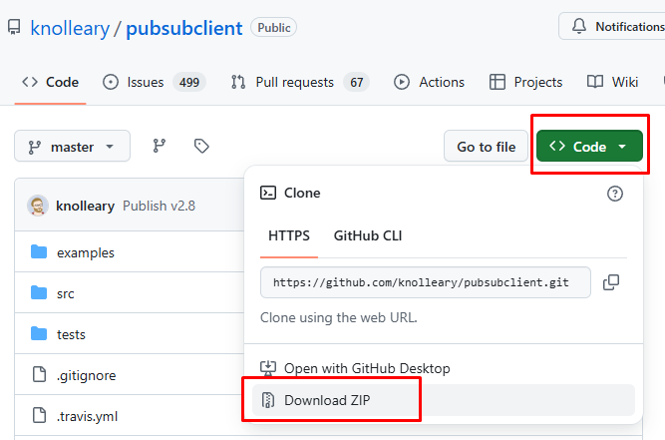
- Update Arduino IDE using the downloaded library file, follow step below
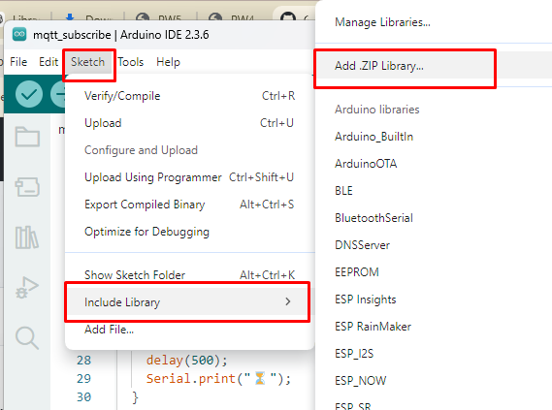
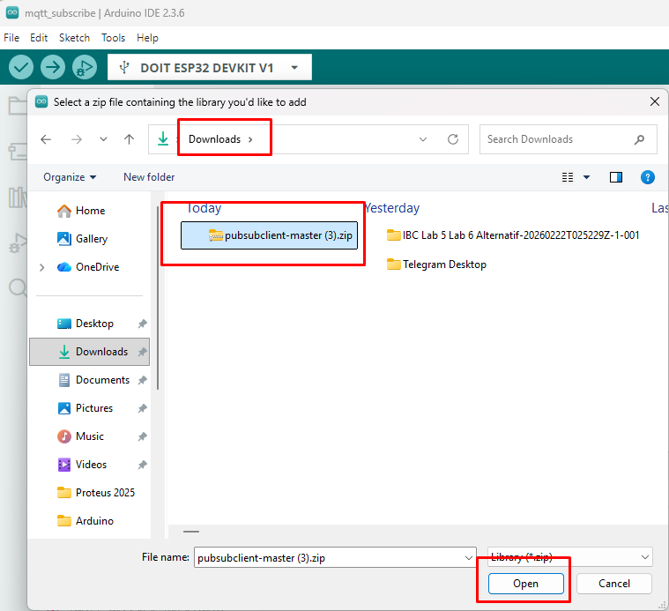
- You will get notification “library installed”
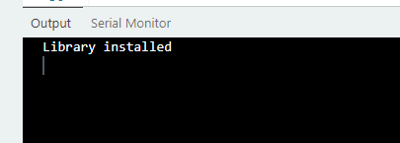
- Upload coding
- Copy code from this link : https://github.com/zulkeflipolimas/DEC30252-Student/blob/main/PW4/mqtt_subscribe.ino

- Modify the blank spot with suitable credential
  - Wifi SSID
  - Wifi Password
  - Broker Server (refer Node Red broker server link in MQTT OUT Nodes)
  - Subscribe Topic (refer Node Red topic in MQTT OUT Nodes)

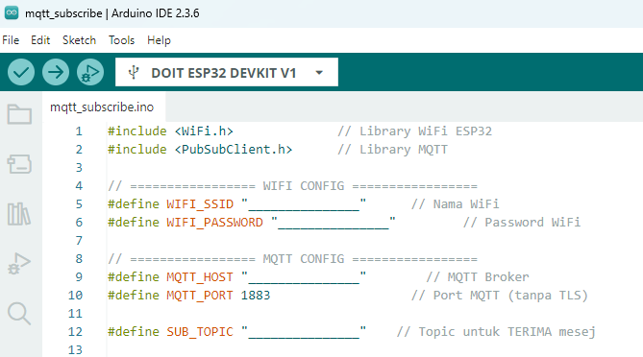

- Upload the code to the ESP32 board. Wait for the upload to finish.
- Open the Serial Monitor in Arduino IDE.
- Set baud rate to 115200.
- Observe the ESP32 connecting to WiFi and the connecting to MQTT server
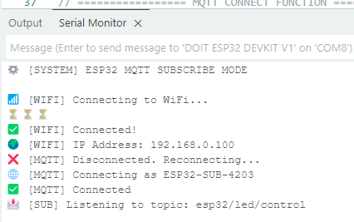

Receiving and Processing MQTT message
- Test the ON button on Node Red deployed dashboard
- Observe the ESP32 LED, the LED should turn ON
- Observe the Serial Monitor:
  - The received topic and message should be displayed.
  - The LED status should be indicated as ON.

- Test the ON button on Node Red deployed dashboard
- Observe the ESP32 LED, the LED should turn OFF.
- Observe the Serial Monitor:
  - The received topic and message should be displayed.
  - The LED status should be indicated as OFF.

Result Task 1
- Show the screenshot of your Serial Monitor that show your Wi-Fi hotspot and MQTT is connected to the broker

- Complete the table with your observation
Description | LED on ESP32 | Serial Monitor
ON Button pressed
OFF Button pressed

- Screenshot the mqttCallback function

- Sketch the MQTT Communication Diagram for this task
PUBLISHER | MQTT BROKER | SUBSCRIBER

Continue to Task 2

Procedure Task 2
Node red setup in browser

- Modify the nodes for Task 1 in Node Red
- Add the following nodes

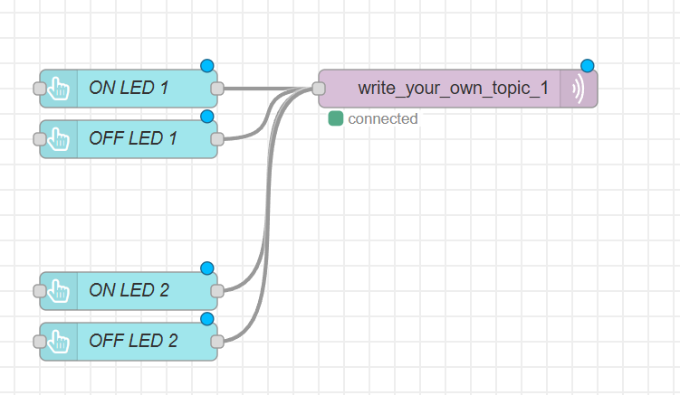

- Setup MQTT OUT
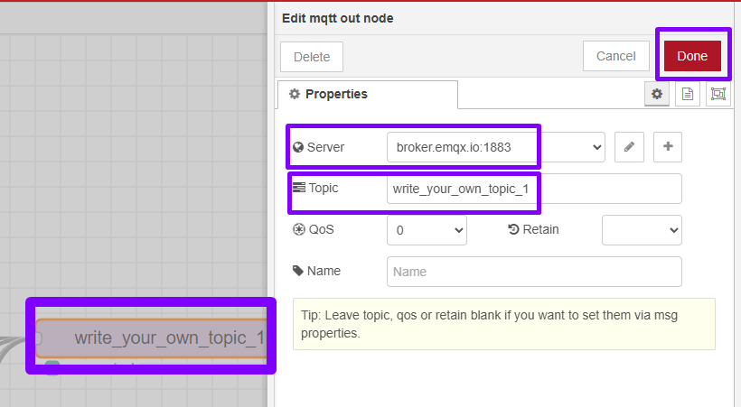

- Setup Button ON led 1
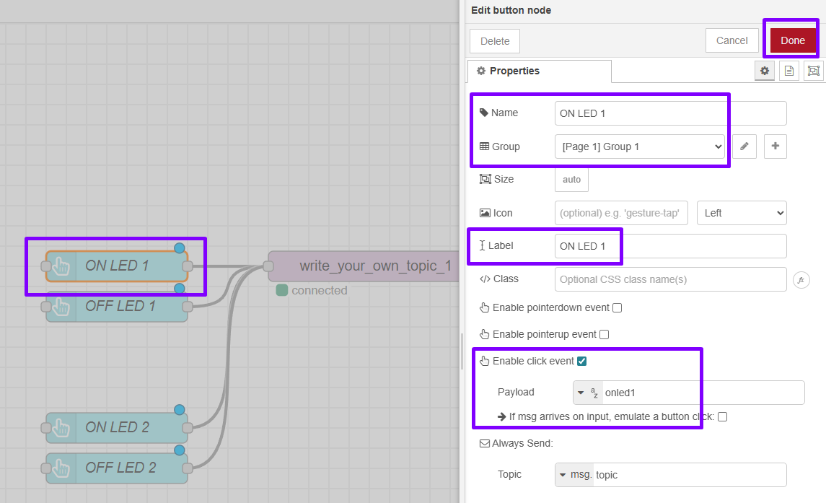

- Setup Button OFF led 1
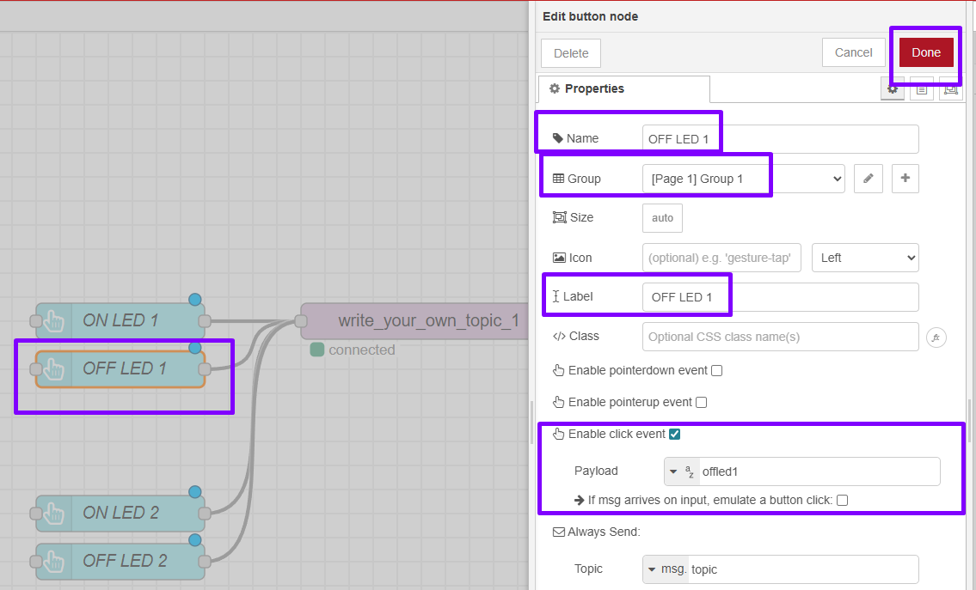

- Setup Button ON led 2
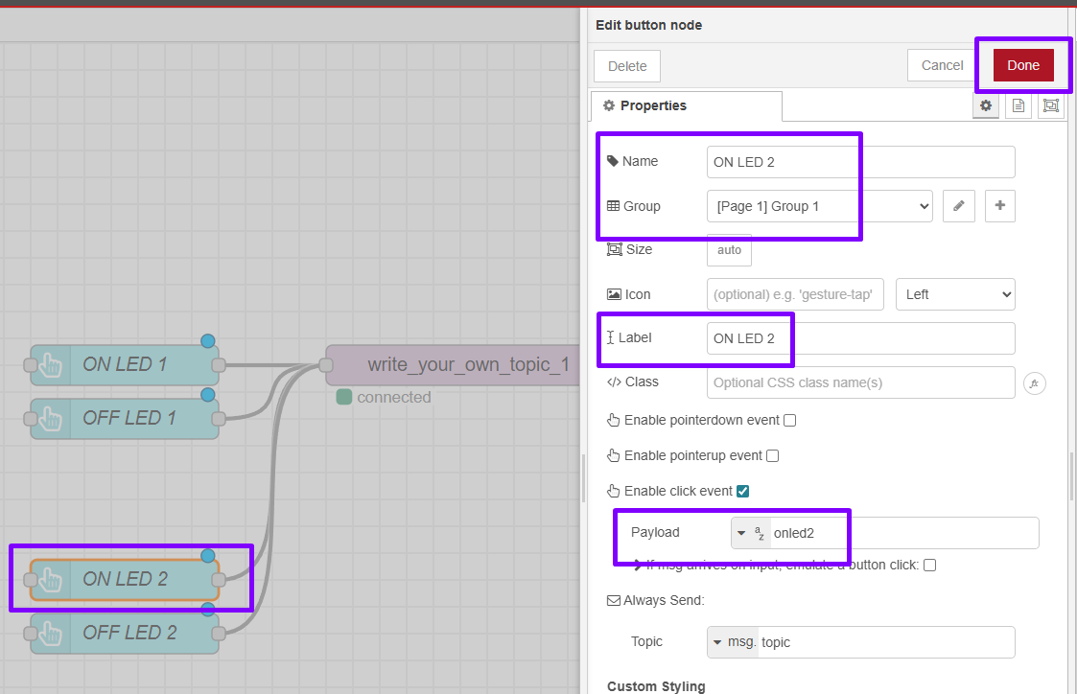

- Setup Button OFF led 2
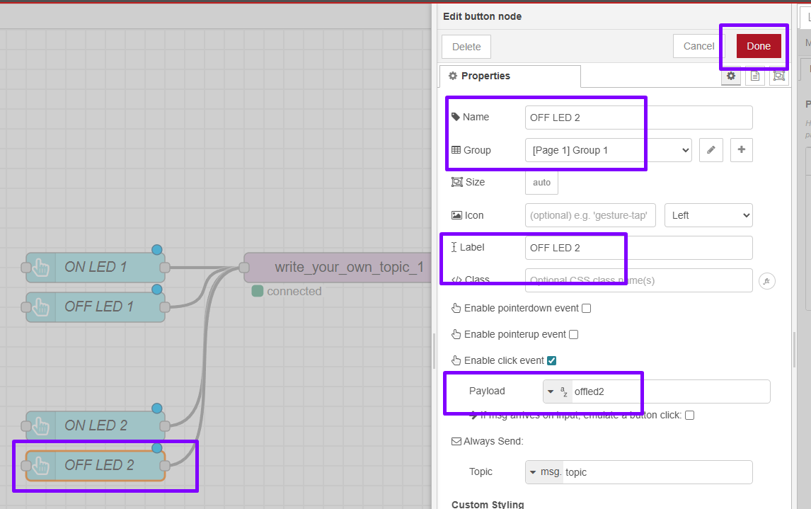

- After Setup is done,click deploy

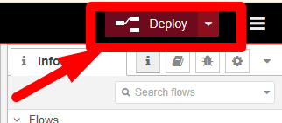

- Open dashboard
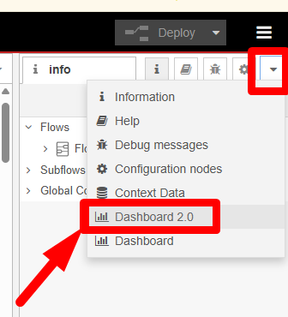

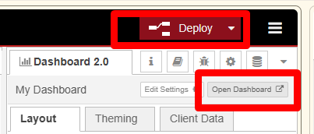

- The deployed dashboard in browser, is shown below.

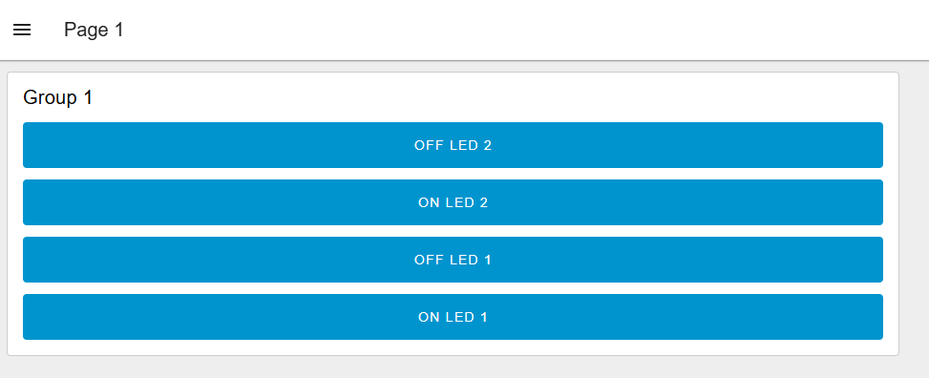

- Split and Arrange Buttons into Group
- Go to Right Tab, Click Dashboard 2.0, Layout, Pages

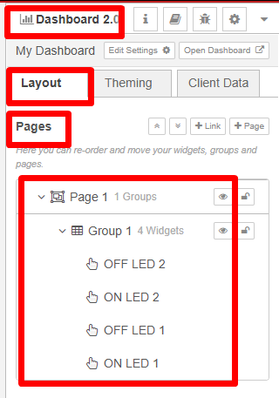

- Click Page 1 , click + symbol (Add Group)
- Rename LED 2
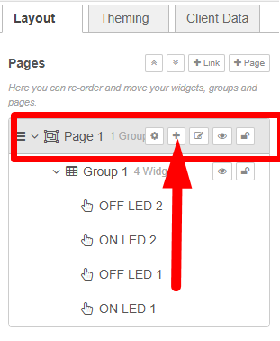

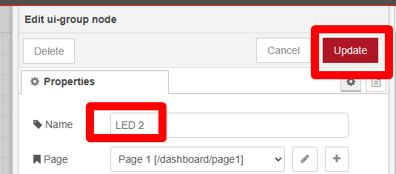

- You can rename,delete and set paramaeter by clicking gar button for each Group

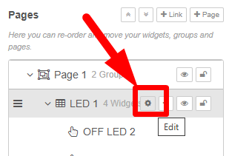

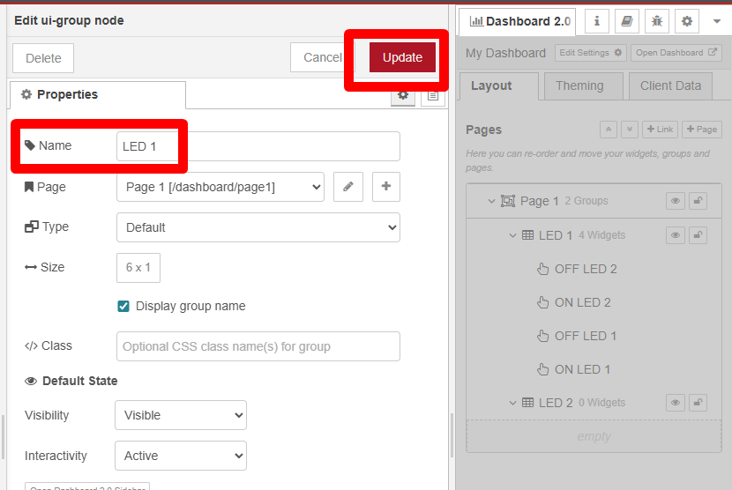

- Arrange the button for each LED Group
- To Arrange you can use Drag and Drop or Double Click on Node, and assign manually
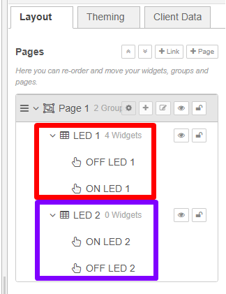

- Deploy again, after make any changes

- The deployed dashboard in browser, is shown below.

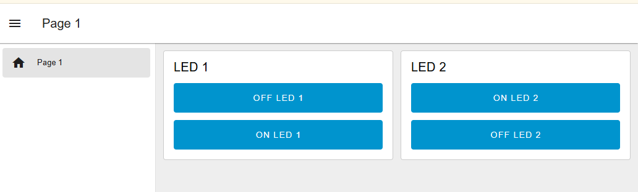

Circuit Setup using Hardware
- Connect the Hardware
- Refer the schematic diagram provided
- Check polarity and resistor value to make all will function properly

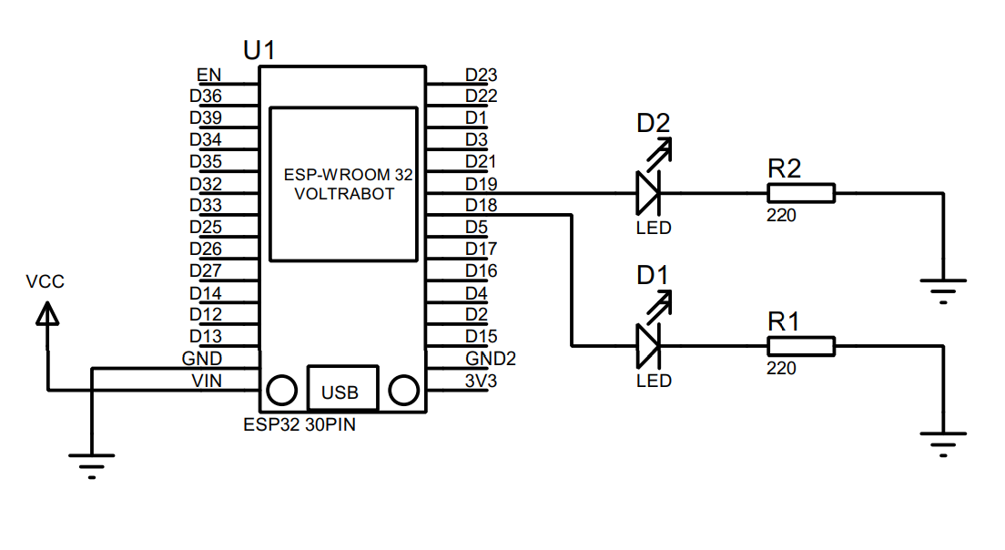
- Continue the setup for Arduino IDE

Setup codes in Arduino IDE
- Open Arduino IDE
- Copy code from this link : https://github.com/zulkeflipolimas/DEC30252-Student/blob/main/PW4/mqtt_task2.ino

- Modify the blank spot with suitable credential
  - Wifi SSID
  - Wifi Password
  - Broker Server (refer Node Red broker server link in MQTT OUT Nodes)
  - Subscribe Topic (refer Node Red topic in MQTT OUT Nodes)

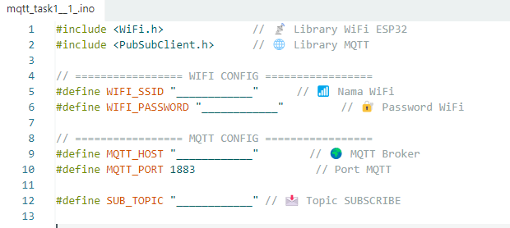

- Modify MQTT Callback mqttCallback() to setup incoming MQTT messages and controls LEDs based on received commands

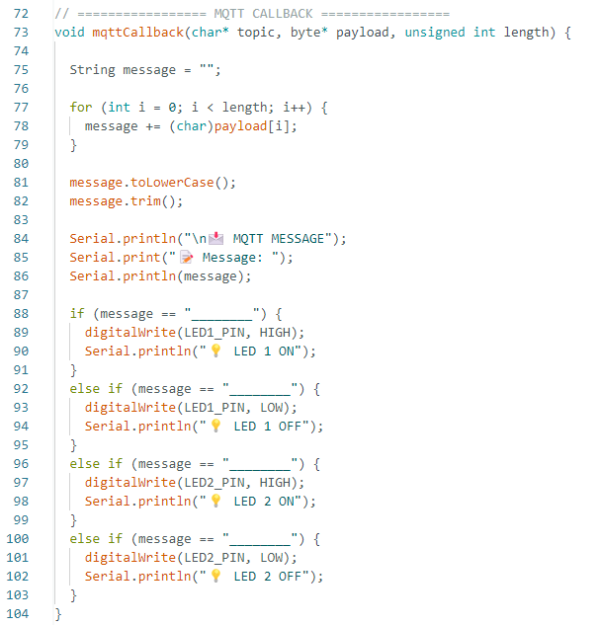

- The message must be the same with the Payload setting for each button in Node Red. Each payload message is unique for each button to avoid conflict.

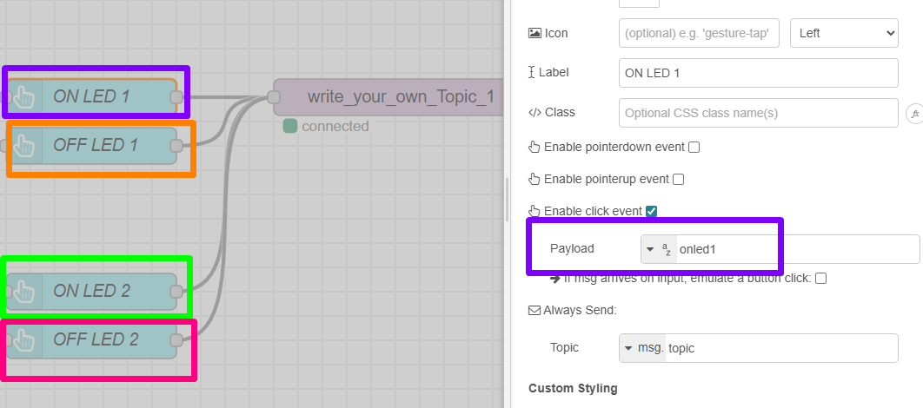

- After done setup wifi credential and the MQTT callback
- Upload the code to the ESP32 board. Wait for the upload to finish.
- Open the Serial Monitor in Arduino IDE.
- Set baud rate to 115200.
- Observe the ESP32 connecting to WiFi and the connecting to MQTT server

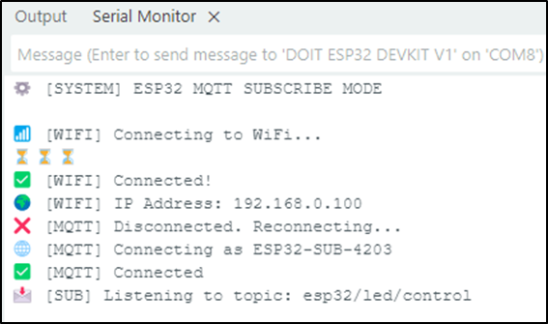

Testing Receiving and Processing MQTT message
- Test the ON button on Node Red deployed dashboard
  - Observe the ESP32 LED, the LED should turn ON
  - Observe the Serial Monitor:
    - The received topic and message should be displayed.
    - The LED status should be indicated as ON.

- Test the OFF button on Node Red deployed dashboard
  - Observe the ESP32 LED, the LED should turn OFF.
  - Observe the Serial Monitor:
    - The received topic and message should be displayed.
    - The LED status should be indicated as OFF.

Result Task 2
- Show the screenshot from your observation
Description | LED on ESP32 | Serial Monitor
ON Button 1 pressed
OFF Button 1 pressed
ON Button 2 pressed
OFF Button 2 pressed

- Screenshot the mqttCallback function

- Sketch the MQTT Communication Diagram for this task
PUBLISHER | MQTT BROKER | SUBSCRIBER

PROCEDURE
Task 3
Circuit Setup using Hardware
- Connect the Hardware
- Refer the schematic diagram provided
- Check polarity and resistor value to make all will function properly

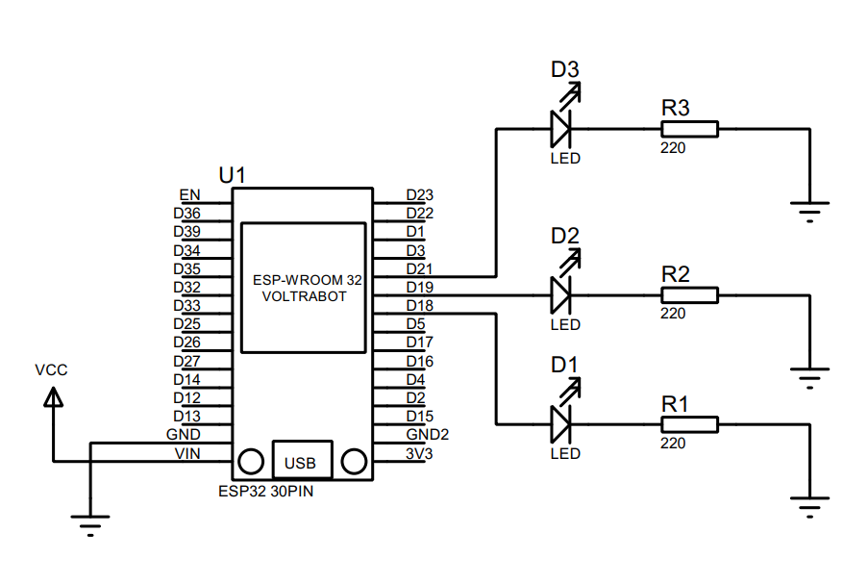

- Continue the setup for Arduino IDE and Node Red

Result Task 3
- Show the screenshot from your observation
Description | LED on ESP32 | Serial Monitor
ON Button 1 pressed
OFF Button 1 pressed
ON Button 2 pressed
OFF Button 2 pressed
ON Button 3 pressed
OFF Button 3 pressed

- Screenshot the NodeRed Nodes for Task 3

- Screenshot the mqttCallback function

DISCUSSION:
Discuss on the observed result.

CONCLUSION:
Summarize whether the findings supported the hypothesis, possible sources of error, and what was learned from the experiment.

